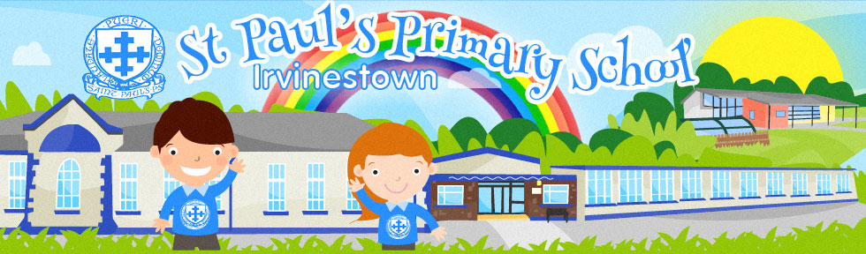
St Paul’s Primary School
OPEN EVENING
For Prospective Pupils & Parents
Tuesday 8th January 2019
6pm

Come along and meet the Staff and Pupils of St Paul’s.
Primary 1 Admission Procedure is available via the Education Authority website from 2nd Jan 2019 until 31st Jan 2019
https://www.eani.org.uk/parents/admissions

Tel: 028 6862 1133 | Email: amolloy164@c2kni.net | Web: http://www.stpaulspsirvinestown.com

