St. Paul’s
Primary School
Irvinestown

Prospectus
2021 - 2022

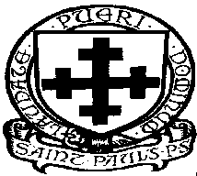
Welcome
Thank you for considering St. Paul’s Primary School as a suitable school for your child.

In St. Paul’s we recognise the great trust parents place in the school of their choice for the education of their child. We work tirelessly to ensure that our pupils receive the best educational experience possible. We set very highs standards for our teaching staff, ancillary staff and pupils in a caring and supportive challenging environment.

Strong links between parents and the community in St. Paul’s are actively encouraged and are viewed as vital to the continued success of our school.

As a Catholic school, St. Paul’s is wholeheartedly committed to the spiritual, moral, personal and social development of our children and the fostering of Christian values for life in an inclusive enriching environment. Our pastoral care is inspired by Christ the Good Shepherd and his faithful love for his flock. This love is made visible by the school’s approach to its caring role and permeates every aspect of school life.

I trust that you will find the information in our prospectus helpful and informative. If there is any further information you require please contact the school and we will be happy to answer any of your queries.
Due to Covid restrictions we cannot show you around our school but we will do so as soon as this is possible.

I hope to see you and your child in September 2021 and look forward to working with you in an open, productive and harmonious way to secure the best possible education for your child.

Mrs A. Molloy

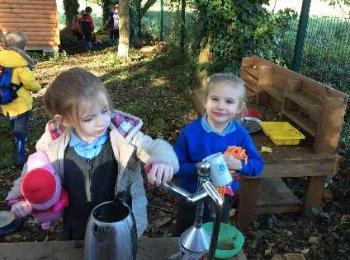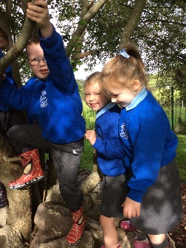
Pupil Comments

P5. I like my school because there are rewards when you are good. The worry box stops any bullying going on and the teachers are friendly.
What I like about my school is that when you achieve something you get rewarded and are proud. I like the cross country and the new football pitch. The teachers and supervisors are very kind and helpful. I like ‘Pupil of the Week’. I like the way there is lots of space to play. I love sports day and I like art a lot.

P1. I like the interactive whiteboard.
I like the football pitch.

P2. I like our time in the Forest School.
I like making stuff and Golden time.

P4. What I like about school is that we are a family and we are all friends.
St. Paul’s is a caring school. I like the teachers and it is the place to make friends
I love St. Paul’s, I like the fruit, football, cross country, PE and art. I enjoy reading the books.

P7. I like being at St. Paul’s because everybody is very friendly and helpful, adults and children. When I come in the morning there is always a warm welcome. If I have any problems the supervisors, teachers, secretary and Principal always help out no matter how busy they are. St. Paul’s gives us the chance to do many sports and different activities. I have really enjoyed doing them. I have enjoyed my time and made lots of friends.

Mission Statement

St. Paul’s in partnership with parents and the community will strive through effective teaching to enable pupils to discover and develop, to the full, their talents, aptitudes and abilities in a caring, inclusive, supportive environment, seeking for excellence and permeated by our Catholic ethos, so that ultimately they will be able to participate actively, productively and responsibly in society now and in the future.

Core Values

- Spirituality, love & compassion

- Professionalism & integrity

- Commitment & responsibility

- Solidarity & teamwork

Openness & honesty

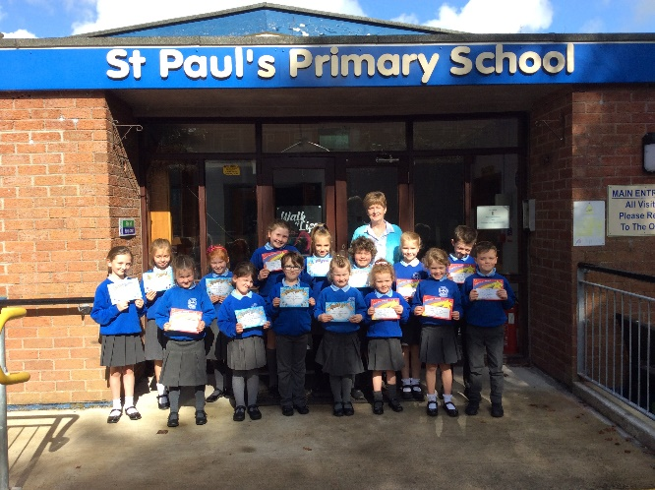
- Excellence

- Flexibility

- Optimism

- Innovation

Our Aims in St. Paul’s

- To appreciate the uniqueness, worth and beauty of each child, seeing the goodness of God reflected through each one.
- To promote and nurture in our children the Catholic faith inculcating attitudes of Christian love.
- To provide a warm, friendly, caring, safe and supportive environment for pupils to ensure their overall happiness and well-being.
- To foster and promote high levels of confidence, self-esteem, self-discipline responsibility and independence in our children.
- To promote an inclusive culture where all children feel important and valued members of our school community fully integrated into school life.
- To create positive, self-motivated, enthusiastic, life-long learners who can, with confidence, take their place in society.
- To equip children with the necessary communication, interpersonal and self-management skills to cope with an ever changing world
- To create a positive attitude to learning by offering an exciting, stimulating child-centred curriculum that is appropriately differentiated to meet the needs of all children.
- To harness, develop and celebrate the talents and strengths of all children in a holistic way, (spiritually, morally, culturally, intellectually, emotionally and physically), celebrating academic and non-academic achievements.
- To promote strong positive and purposeful links between home, school and community so that the best possible learning partnership and environment is created for the children.

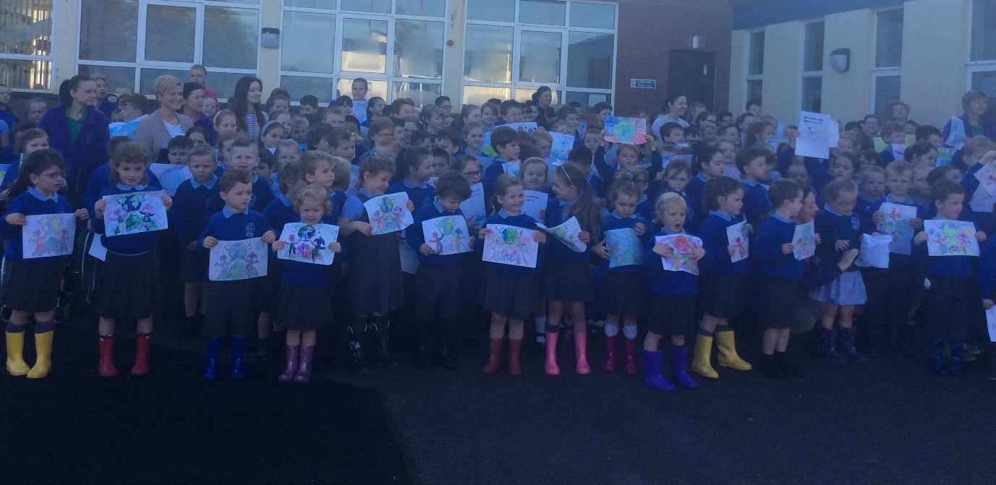
School Ethos

St. Paul’s has a very positive ethos. It is a pleasant place to work and learn and the pupils feel secure, happy and valued. Standards of behaviour are exemplary. Staff morale is high and relationships between pupils, staff and parents are excellent. In everything we do we have the highest expectations. In St. Paul’s, we aim for the highest academic standards but also seek to ensure that all talents (artistic, musical, sporting, dramatic etc.) are developed to the full. Through the fostering of high self-esteem we try to ensure every opportunity is given to all members of the school to discover and develop whatever talents they have to the highest level of which they are capable. We welcome and encourage the involvement of parents, governors, friends, former pupils and members of the local community in the development of the school.
We believe it is important to develop in our pupils, qualities such as leadership, responsibility and self-resilience coupled with the ability to work effectively in teams and to empathise with the needs of others.

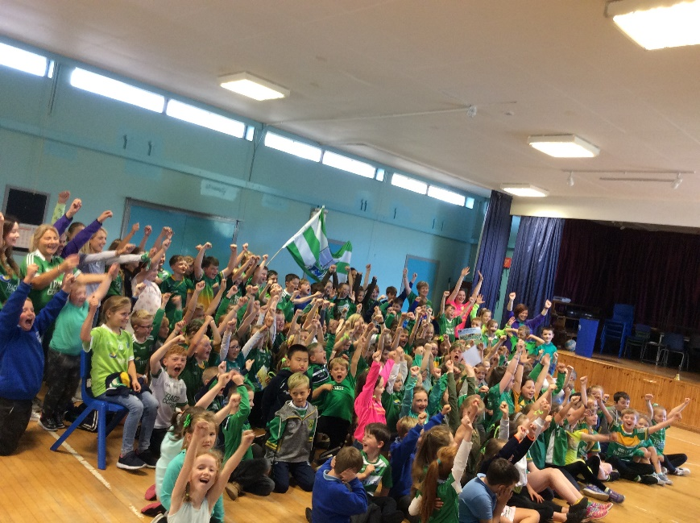

Information about the School

St. Paul’s is a co-educational Catholic Primary School with an enrolment of 216 pupils. It was formed in 1966 on the amalgamation of the former Irvinestown Boys’ Primary School, Whitehill Primary School, Coa Primary School and Irvinestown Girls’ Primary School on the site of which the school now stands.

The catchment area is the parish of Devenish. The pupils come approximately two-thirds from the town and one-third from the rural areas.

It has a staff of Principal and nine teachers, an ancillary staff of caretaker and two cleaners, one secretary and twenty two Classroom Assistants.

Presently the enrolment stands at 216.

The school comprises – 8 classrooms, one Principal’s office, an administration office, an assembly hall, a library, a Circle Time room, two SEN resource rooms and a computer suite. The Education Authority provide the school meals kitchen.

Within the school grounds there are two playgrounds, a grass football pitch, a Forest School area and an all-weather football pitch.

As a Catholic school, St. Paul’s is committed to the Statement of Aims of Catholic Schools, which reflects Christian teaching and the value of the Church. The school will endeavour to create an effective partnership between the Church, parents and the school so that this ethos can be maintained and developed.

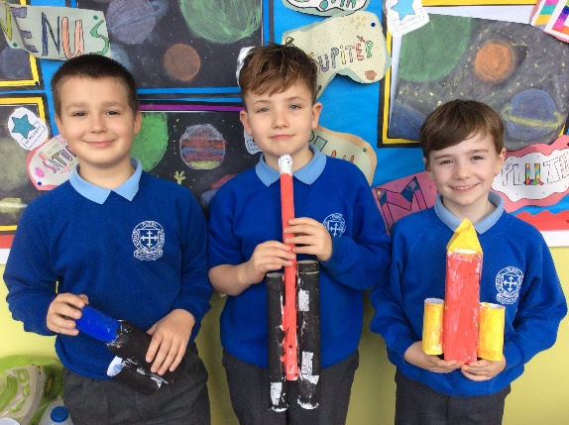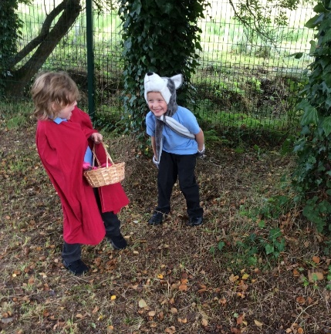

Necarne Community Nursery

St. Paul’s Primary School is the host school for Necarne Community Nursery. Necarne Nursery opened in 2002. The Nursery is situated within the grounds of the school and maintains close links with the main school. We provide one nursery session running from 9.15am – 11.45am providing for 30 children.

Necarne Nursery maintains a safe and secure environment in which children can develop socially, intellectually and physically, at their own pace. We accept and treat each child as an individual in their own right whilst delivering a varied and balanced curriculum. Our curriculum is organised under the six areas of learning of the Nursery Curriculum, and during the course of the nursery day, children will experience a rich variety of challenging play activities and other stimulating experiences.

All information regarding Necarne Nursery open enrolment can be viewed on the school website or on the Education Authority website.

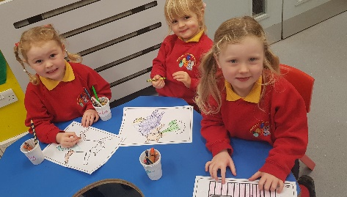
“Children
learn as they
play. Most
importantly, in
play, children
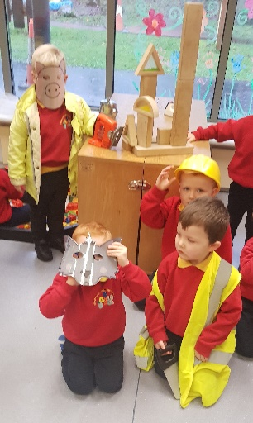
learn how to
learn.”
Fred Donaldson

The Primary Curriculum in
St. Paul’s

The teaching staff in St. Paul’s strive to present children with lively and exciting curriculum experiences that will enable them to reach their potential in all areas of study.

The Primary Curriculum is set out in the following Areas of Learning

- Language and Literacy
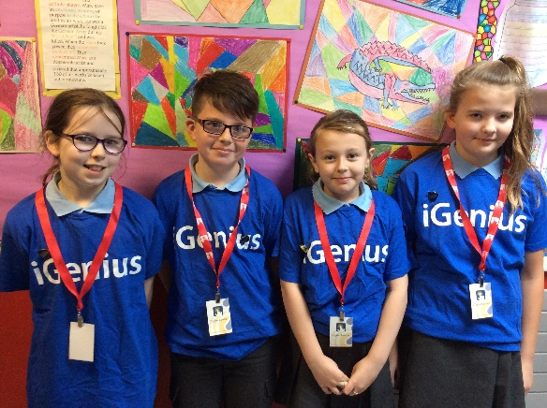
- Mathematics and Numeracy
- The Arts
- The World Around Us
- Personal Development and Mutual Understanding
- Physical Education

At the heart of the curriculum lies an explicit emphasis on the development of skills and capabilities for lifelong learning and operating effectively in society. Through opportunities to engage in active learning contexts across all areas of the curriculum children will progressively develop:

Cross Curricular Skills

- Communication
- Using Mathematics
- Using Information and Communications Technology

Thinking Skills and Personal Capabilities

- Thinking, Problem Solving and Decision Making
- Self-Management
- Working with Others
- Managing Information
- Being Creative

Our Approaches to Learning and Teaching in the Primary Curriculum

- Children learn best when learning is interactive, practical and enjoyable
- Teachers will make use of a wide range of teaching methods, balancing whole class, group and individual activities, to engage children in effective learning
- Children will experience much of their learning through well-planned and challenging activities
- Children will have opportunities to make choices and decisions about their learning
- Children are given equality of opportunity to learn in a variety of ways and in different groupings.

In order to ensure the appropriateness, challenge and breadth of our curriculum, the school continuously monitors and reviews the work undertaken. Thus through the process of continual review, careful planning and regular assessment, each child experiences a broad range of activities which are appropriate to the child’s needs and secures a learning process which is continuous and progressive. Pupil performance and development is evaluated by using appropriate assessment techniques and the outcomes are made available to parents.

While high standards in Literacy and Numeracy are a constant focus in our school, our other core priorities for improvement are identified within our School Development Plan on an annual basis.

The organisation of education at St. Paul’s Primary School ensures that pupils of similar age ranges are taught together in mixed ability classes. The curriculum delivered within each class will be differentiated to ensure that all pupils are catered for.

The learning phases in the school are:

Foundation Stage Nursery, P1, P2
Key Stage One (KS1) P3, P4
Key Stage Two (KS2) P5, P6, P7

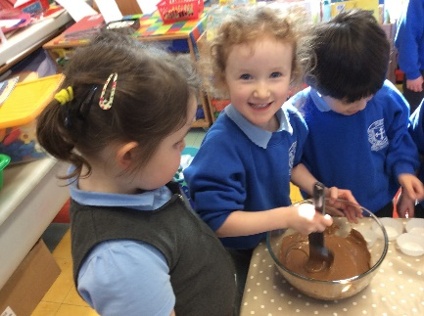
The school promotes children’s ‘Play Based Learning’ in the Foundation Stage in P1 and P2. This leaves a firm foundation for future development throughout the school.Through opportunities to engage in active learning contexts across all areas of the curriculum, children will progressively develop:

Religious Education

Our Religious Education Programme is based on the Grow in Love Programme.

It prepares each child for participation in the liturgy and sacraments of the Catholic Church. Religious Education is not confined to the timetabled programme within the school but pervades the whole life of our school.
The totality of experience in the home, the school and the parish contribute to the spiritual growth and development of the pupil. The school will work with parents and the parish to strengthen the partnership.
The priest will be actively involved in the life of the school through regular visits, School Masses, preparation for the Sacraments etc.
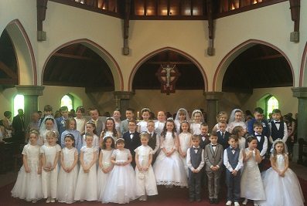

Language & Literacy

This area focuses on Talking and Listening, Reading and
Writing. It develops the skills that enable children to
interact effectively in the world around them. Our
school library gives children the opportunity to choose
from a wide variety of fiction and non-fiction books that
will help foster positive reading habits.

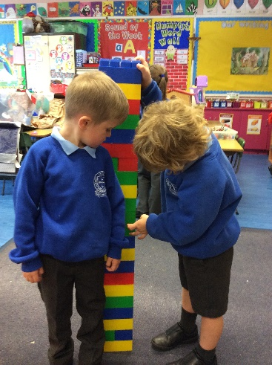
Mathematics & Numeracy

Teachers enable children to develop knowledge, understanding and skills in: Sorting, Patterns and
Relationships, Number, Measures, Shape and Space,
Handling Data and Processes in Mathematics. Children have the opportunity to explore a range of computer packages and internet sites to enhance their understanding of mathematics.

Information Technology

Throughout their time at St. Paul’s, we offer our pupils a wide range of ICT experiences. Learning with technology takes place across the curriculum and the children greatly enjoy using ICT resources in a range of creative ways.
Classrooms are equipped with interactive whiteboards and we also have a dedicated Computer Suite. Pupils also enjoy using mobile devices such as laptops and iPads which open up new opportunities for using ICT in school.
Some of the activities pupils currently participate in are: making presentations; making movies and animations and much more! With advances in technology happening all the time, pupils’ work in ICT is always changing, but we are committed to keeping up to date so they are well equipped for whatever the future may bring.

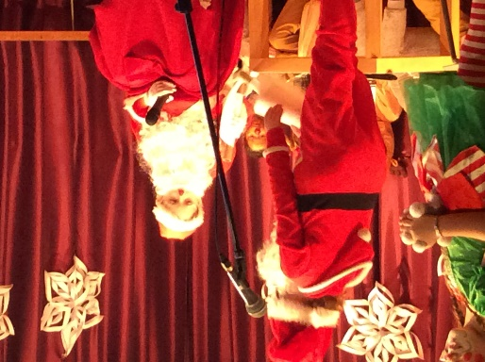
The World Around Us

This Area of Learning has combined to provide a balance of experiences across the areas of History, Geography, Science and Technology. This provides opportunities for children to develop an awareness of themselves, their place in the world and their environment. The school operates an Eco-Team who takes lead in helping to educate the school and local community about environment issues and sustainability.
Physical Education

Physical Education is an important part of our curriculum as we believe that specific attention should be given to the physical development, health and well-being of our pupils.
During each year our pupils participate in a range of activities such as, athletics, dance, games, gymnastics and usually the P6 and P7 classes have a series of swimming lessons at the Lakeland Forum with a qualified coach. We facilitate many after-school activities such as football, netball, camogie, hurling, soccer.
Our desire is that our pupils will have self-confidence and high self-esteem with a positive attitude towards physical activity. We are continually striving to encourage our pupils’ awareness and understanding of the immense value of the importance of healthy life styles.
The Arts

The contribution of Art, Drama and Music to the development of every child is highly valued in our school.
Children experience a wide range of enjoyable and challenging activities. Children also have opportunity to participate locally in shows, competitions and festivals.

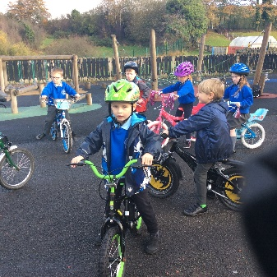

Health Education

St. Paul’s is a Health Promoting School and we are aware that the habits formed in early years stay with us. We actively promote healthy lifestyle messages both in and out of the classroom. Our “Healthy Break” scheme encourages all pupils to eat a healthy snack for break each day. We also strongly encourage our pupils to eat a healthy lunch each day. School meals are prepared in accordance with nutritional guidelines. We participate in the annual “Munch Box Challenge”. Pupils are encouraged to drink water in class, both after exercise and as required throughout the school day. Healthy lifestyles are studied and encouraged both through classroom teaching and also through various visits from outside agencies, such as Action Cancer and British Heart Foundation. We encourage pupils to consider the health benefits of walking to school through our “Walk to School” days.

Learning Support/Special Educational Needs

In St. Paul’s, we pride ourselves that each teacher provides a full programme of work for all children in their class, whatever their ability. Pupils with Special Needs and Specific Learning Difficulties are quickly identified and catered for using the expertise within the school and/or by utilising the advice and support of the Education Authority Psychology Service.
A range of provision is made for children who may have learning difficulties. The school’s Special Needs policy, which is based on the SEN Code of Practice provides further details and is available on request. Whatever arrangements are proposed, you will be fully consulted. Your support and encouragement will be a key element in helping your child make appropriate progress. The school’s Special Educational Needs Co-ordinators (SENCO) are Mrs Rachel Mulholland and Mrs Sharon Owens.

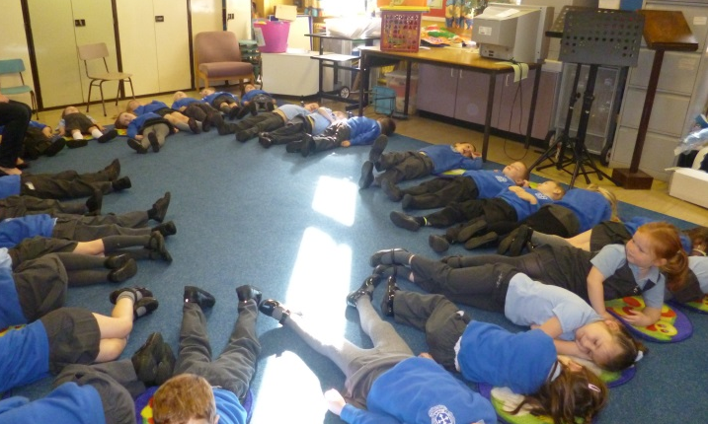

Assessment

Pupils’ progress will be continuously monitored throughout the year. This builds on what already happens in the classroom and focuses on continuous monitoring by your child’s teacher about each child’s knowledge, understanding and skills development.
Internal assessment is robustly monitored.
Teachers can use different assessments and you will have the chance to meet your child’s teacher in the first term and talk through their progress in a meaningful way.
Diagnostic assessment will help support your child in their learning by helping teachers to find out if they are having any particular difficulties, or if they are finding their learning too easy and need more of a challenge.

.

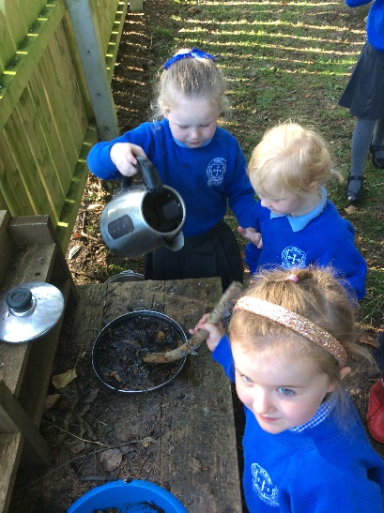
Extra-Curricular Provision

The school offers a wide variety of activities, run usually outside normal school hours under the guidance of members of staff.

These include Football, Camogie, Netball, Drama, Yoga, Mindfulness, Film Club, French, Spanish, Numeracy, Literacy, French, Phonics, ICT, Choir, Drums, Accordion and Art.

Educational visits to places of local interest figure prominently in the school curriculum to enhance and enrich the children’s learning experiences.

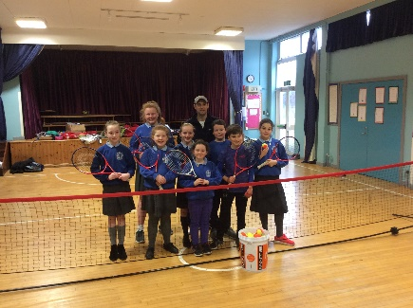
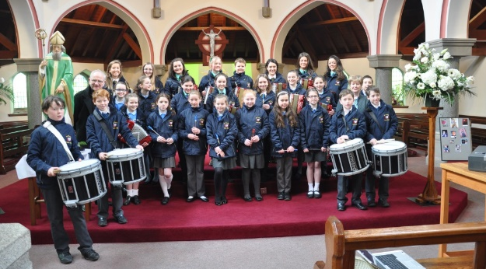

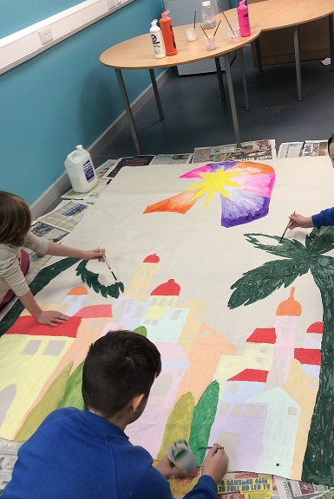
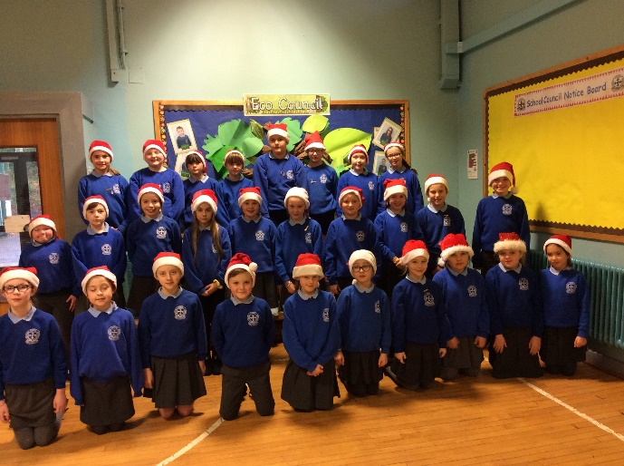

Homework

Homework is an important part of school life. It provides children with an opportunity to practise and consolidate work done in school. It encourages the development of self-discipline and independence. It gives you an opportunity to see what your child has been doing in school. Homework is set regularly for all children. For P1 children, homework will mainly focus on reading, early mathematics and related activities. P2 and P3 children will continue with reading and mathematics along with the introduction of spellings and tables. In P4 to P7 a range of learning and written homework will also be included. As your child progresses through the school, homework will gradually become more demanding but less direct parental supervision should be required. Children are provided with a Home/School Link Book to ensure regular communication with parents re homework.
A copy of the school’s homework policy is available on request from the Principal.

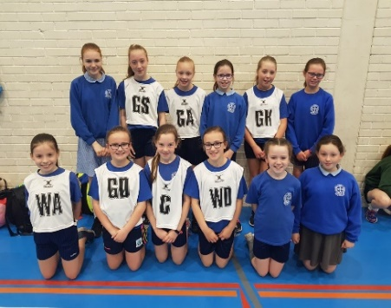

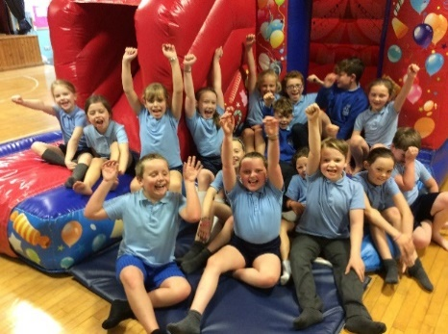

Home Links

We have a strong commitment to home school links.

We recognise and value the important role parents play in their child’s education. It is important that pupils get the same positive messages about learning from both home and school. Consequently, parental help is greatly valued during homework support and in activities such as Accelerated Reading and Mathletics. Parents are kept informed of their child’s progress throughout the year. Every effort is made to ensure that parents feel welcome in our school and are kept informed of their child’s needs and progress and what is happening in the life of the school.
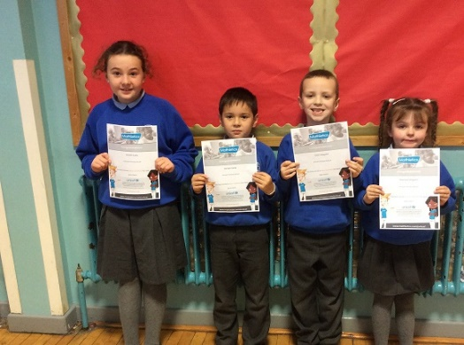

Parental Concerns

If a problem concerning a child occurs, parents are encouraged to contact the school. They are advised to discuss the matter with the class teacher in the first instance. The Principal will also be available to discuss any matters of concern. We request that parents contact the class teacher via the Main Office if they wish to make an appointment. A copy of the Parents’ Complaints Procedure is sent out annually at the beginning of the school year or is available on request.
How will I know how my child is doing?
Curriculum Meetings are usually held in October for each year group. Parent/Teacher consultations are held in November. An annual written report/pupil profile is issued in June.
A summative Record of Achievement is issued in Primary 7 detailing a child’s achievements, both academic and non-academic, throughout their time at Primary school.

Links with the Community

The school values its place within the local community and it strives to build and develop links with the community.
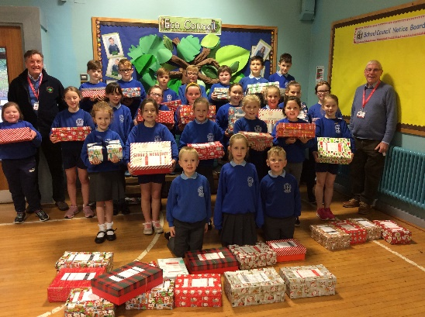
The pupils and staff of the school attempt to support various agencies who work with different groups at a local, national or international level. The pupils and staff have engaged in fundraising for St. Vincent de Paul, Society of Missionary Children, SMA Fathers, and other appeals. It is intended that the school will continue to support these groups.

The quality of educational provision for our pupils is aided by visitors coming to the school and sharing their experience and skills with the pupils. Such visitors will be encouraged and developed on an on-going basis. Children also make use of local community facilities to enrich the curriculum.

The staff of St. Paul’s will always strive to ensure that the pupils have access to a broad range of external resources to enhance their educational experience.
We participate in the Shared Education Programme and the Extended Schools Programme to enhance and enrich the provision for all children.

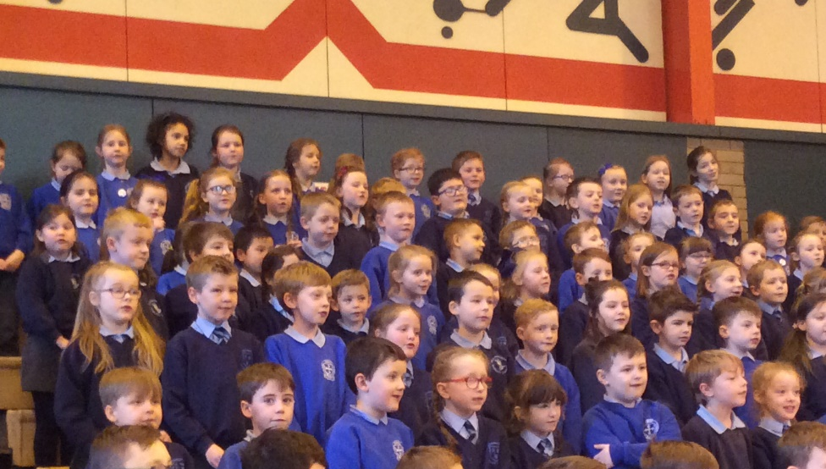

Pastoral Care Policy
St. Paul’s prides itself on its outstanding Pastoral Care. Last year we were awarded the Derrytrasna Award. This is presented each year to one Primary School in Northern Ireland which has demonstrated exceptional pastoral care in supporting the emotional health and well-being of pupils and their families.

The Pastoral Care Policy of St. Paul’s is inspired by Christ the Good Shepherd and his faithful love of his flock. This love is made visible in the school’s approach to its caring work and permeates all aspects of school life.
At all times in St. Paul’s we strive to promote the emotional health and wellbeing of our pupils promoting their confidence and self-esteem. We focus on the possible achievements of our pupils both academic and non-academic. It is fostered in many ways such as positive marking and classroom rewards and incentives. We place a strong emphasis in St. Paul’s on creating an atmosphere based on positive relationships between teachers and non-teaching staff, pupils and parents. We believe this underpins a secure, caring and safe environment for our pupils to optimise their learning.

We have successful School and Eco Councils in St. Paul’s to give pupils a forum for discussion and a voice in whole school issues.

Positive Behaviour
The school adopts a positive approach to behaviour, expecting all pupils to behave in a responsible manner by always showing consideration, courtesy and respect for other people. The co-operation of parents is sought to ensure we maintain high standards in terms of pupil attendance, punctuality, personal appearance, wearing of school uniform, having the proper equipment for learning and the supervision of homework.
If problems arise, we like to involve parents at an early stage. We hope that you, as parents, will do the same with us. A copy of the school’s Positive Behaviour Policy/Anti-Bullying Policy can be inspected on request.
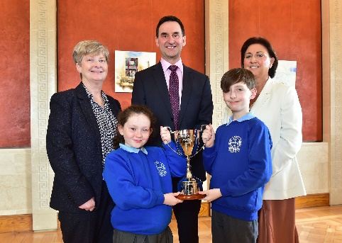

Child Protection & Personal Safety

The welfare of each child must be paramount and the school has a duty of care to report any concerns about abuse or neglect to Social Services.

All staff are vetted under Education Authority (Western Region) procedures and they all have been trained to be aware of the signs of possible abuse or neglect and of the procedure to follow.
Our Safeguarding Team for Child Protection includes Mrs Molloy (Designated Person, Principal), Mrs Mc Dermott (Deputy Designated Teacher, Vice Principal), Mrs Cox, (Deputy Designated Teacher, Nursery) and Mrs Bronagh Gormley (Governor for Child Protection).

A copy of our Child Protection Policy; Code of Conduct for all employees; all other Pastoral Care Policies and complaints procedures are available in school for those parents who wish to see them.

Drugs Education Policy

As in all matters it is the school’s policy to promote healthy, positive attitudes. Health is perceived, not so much in terms of illness and disease, but as a more positive state of well-being. Drugs Education forms part of a comprehensive Health Education Programme, which contributes to equipping pupils with the skills to manage their lives effectively and make responsible health decisions.
Guidelines for the management of prescribed medicines are in place and parents must complete a medicine administration form. Full details can be found in our Drugs Policy, available from school on request.

Security

The school has a controlled access policy to all areas of school. Parents or others wishing to visit during the school day should use the main entrance doors at the front of the building and report to the school secretary.
Access and areas around school are monitored by CCTV cameras.
Children arriving late for school should also use the main entrance doors as the Irvinestown door is closed at 9.15am.

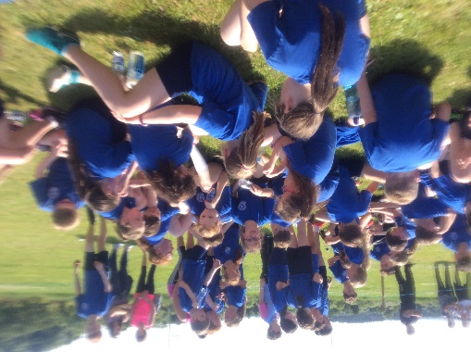

Admission Information

Admissions Criteria
The school policy is to enrol only those children who have reached compulsory school age (i.e. children born on or between 2nd July 2016 and 1st July 2017).

Primary 1 Intake
Open enrolment criteria and information can be viewed on the Education Authority website. The application process can now be completed online via https://www.eani.org.uk/parents/admissions from Thursday 7th January until Friday 29th January 2021 at 12 noon. If any parent has difficulty with the online application form, please contact the school office and we will provide assistance.

Primary 2-7
Criteria as per P1, where and when applicable and
determined by the spaces available in each year group.

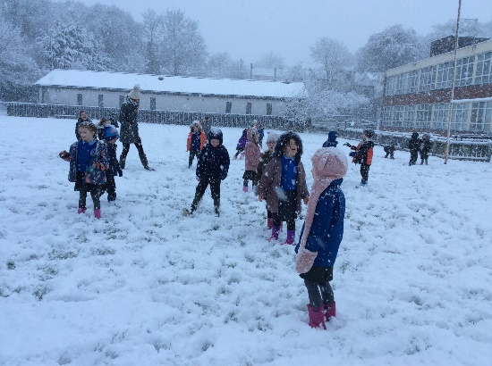

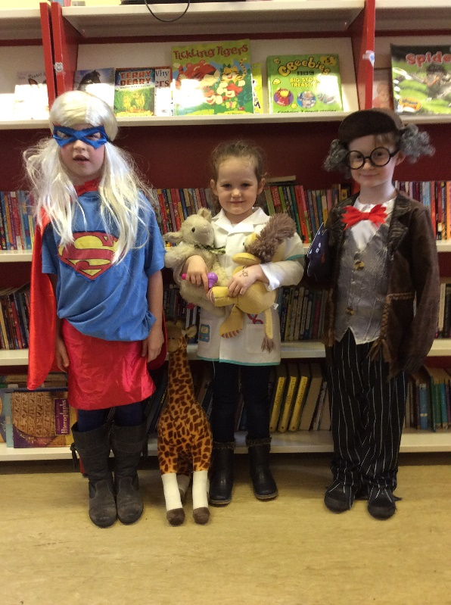
Applications for Admission

It is the parents’ responsibility to ensure that all
information relevant to the admissions criteria is
included on the application form.

An open afternoon for Nursery and P1
children and parents is held in May/June followed by two afternoons when the children will meet their class teachers.

The Principal is happy to meet all other prospective pupils and their parents, to talk to them about the school and to show them round the facilities. We feel it is important to meet with you no matter which year group your child is in.

School Uniform

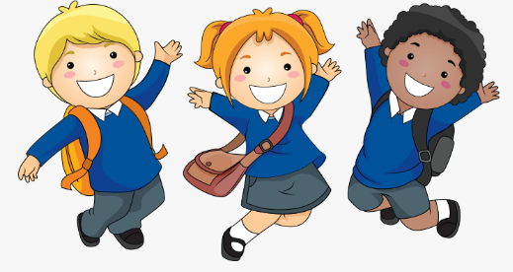
The uniform for St. Paul’s is:

Grey Skirt/Pinafore/Trousers
Pale blue polo shirt
Royal blue Sweatshirt with school crest
Grey Tights/white socks/grey socks
Black shoes
Blue/white checked dress for summer (Optional)

PE UNIFORM
Navy shorts and royal blue t-shirt with the school crest

The School Sweatshirt and PE Uniform is available to purchase from School Days, Enniskillen.

In St. Paul’s, we all take a pride in our school uniform as it gives the children a sense of identity with the school. Please ensure your child’s name is clearly marked on the following:
Coats, All items of school uniform, PE gear and footwear, School bags, Lunch boxes.

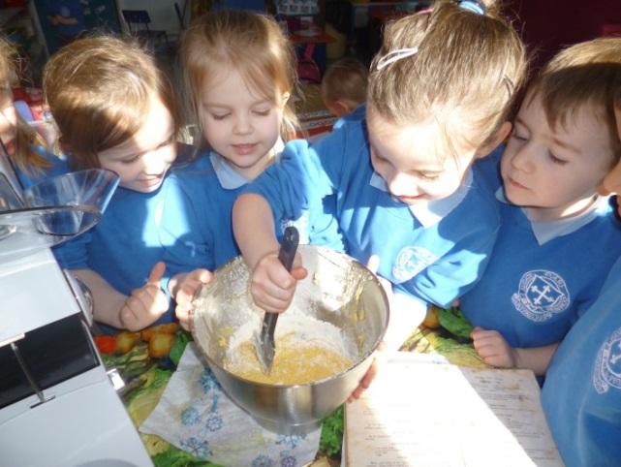

Staff Board of Governors
Principal
Mrs Anne Molloy

Vice Principal
Mrs Josephine Mc Dermott

Teaching Staff
Mrs Terina Cox
Mrs Maria Doherty
Mrs Gail McCaffrey
Mrs Rachel Mulholland
Mrs Michaela Coyle
Mrs Sharon Owens
Ms Eileen Conway
Mrs Josephine McDermott
Mrs Joanne Gallen

Secretary
Mrs Maria Doonan

Classroom Assistants
Mrs Carmel Wilson
Mrs Julie Walsh
Mrs Tanya Mc Kervey
Mrs Fiona Chesters
Miss Emma Timlin
Miss Ciara McCusker
Mrs Claire Singleton
Mrs Nicky Gormley
Mrs Lisa Maguire
Mrs Paula Maguire
Mrs Marilyn Glover
Mrs Martina Begley
Miss Kiera Ormsby
Mrs Carol McMulkin
Miss Martina Johnston
Mrs Donna Cassidy
Mrs Kathryn Bryans
Mrs Louise Mulrone
Mr Declan Dolan
Mrs Mary O’Hanlon
Mrs Mary Burke
Mr James Mc Guigan

Dining Hall Assistants
Mrs Lorraine McNulty
Mrs Pauline McCrossan

Cook in Charge
Mrs Brenda Beacom

Building Supervisor
Mrs Donna Cassidy

Cleaners
Mrs Carmel McElhill
Mr Joey Spratt

Chair of Board of Governors
Fr. Kevin Duffy

Parents’ Representative
Mr Aidan Ormsby

Department of Education Representative
Mr John Maguire

Education Authority Representative
Mr Peter Mulrone
Mrs Geraldine McMulkin

Trustees
Fr Kevin Duffy (Chairman)
Mr John O’Kane
Mrs Bronagh Gormley

Teacher Representative
Mrs Josephine McDermott

Secretary
Mrs Anne Molloy (Principal)

School Hours

Nursery: 9.15am – 11.45am
Primary 1 & 2: 9.15am – 2pm
Primary 3 – 7: 9.15am – 3pm

PLEASE NOTE: As part of our settling in period the school will operate a staggered intake for the first few weeks of the new school term for Nursery children.

Documents available on request
St. Paul’s is committed to open communication with parents. There is a statutory requirement to make certain information readily available for parents and we are very happy to accommodate you. This includes curriculum details, statements of school policy and formal papers issued by the Department of Education. Copies are held in the School Office and can be viewed by arrangement by the Principal.

Visit our school website to get more information about events at St Paul’s PS and get a flavour of school life: www.stpaulspsirvinestown.com

Prospective Parents are welcome to visit our school at any time to observe our facilities at first hand.
If you would like more information about St Paul’s P.S. please contact the School Office. We will be happy to provide you with further details on school policies and procedures and put you on our contacts list for enrolment.

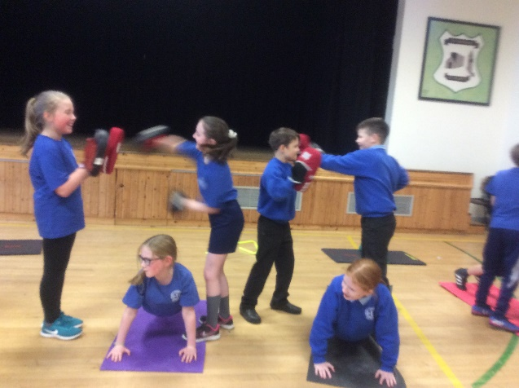

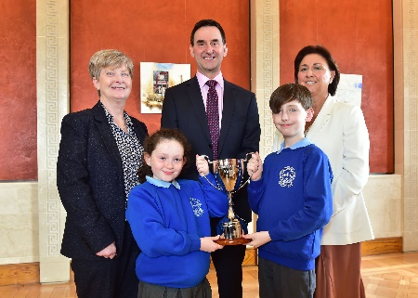

Principal: Mrs Anne Molloy

St. Paul’s Primary School
7 Lisnarick Road
Irvinestown
Co Fermanagh
BT94 1EY

Tel: 02868621133
Mob: 07802881241
Email: amolloy164@c2kni.net
http://www.stpaulspsirvinestown.com/

